DWR/DISE Aquatic Ecology Unit

**Standard Operating Procedures**

Last Revised: [10/25/21] (NK & PF)

Version: 1.1

# Yolo Bypass Fish Monitoring Program: Rotary Screw Trap Sampling

Rotary screw traps are sturdy, relatively easy to move, relatively easy to operate and maintain, and can capture fish without harm in fast-moving water. In accordance with state and federal agency regulations and the Interagency Ecological Program (IEP) Yolo Bypass Fisheries Monitoring Program Study Plan, the YBFMP uses a floating, eight foot (2.44 m) rotary screw trap (RSTR) to collect juvenile and small bodied fishes utilizing the Yolo Bypass. The trap is installed at the lower end of the Yolo Bypass Toe Drain and operated weekdays during January through June. The rotary screw trap sampling objectives are to: (1) examine abundance and species and life history composition of juvenile outmigrants and resident small-bodied fishes; (2) identify temporal and spatial patterns in fish abundance and species composition; (3) examine the effect of physical and environmental conditions on these patterns; and (4) develop an estimate of juvenile salmon residence time using Coded Wire Tags (CWT).

## Equipment:

* + Rotary screw trap (RSTR)/pontoon structure
* Crowder
* Fish hotel (weighted laundry basket)
* Live well screen
* Broom
* Rakes
* Cut resistant gloves
* Boat
* 2 oars
* Bowline
* Motor & gas (during high flows)
* Type III PFD – fitted life jacket
* Type V PFD - throw ring
* Secchi
* YSI handheld (ProDSS)
* 5-gallon buckets (at least 2)
* Large fishing nets
* Small fishing nets
* Small fish measuring boards (2)
* 2 aerators
* Fish clipboard/binder
* Datasheets
* Fish ID keys
* Scientific collection permits
* Pens/pencils
* Screw trap log sheet
* Live well key
* Genetics kit (see Genetics SOP)

## Requirements before operation

### Crew:

A minimum crew of two is required for trap operations. Three people make up a good-sized crew during the peak of the migration, when the workload is high. A field lead, typically an Environmental Scientist, supervises the field crew. The field lead oversees the project, schedules the crew, and maintains communication with crew members over the trapping season.

A successful trapping operation requires a team of professional and technical staff that is dedicated to the success of the project. Winter and spring storm events increase river discharge and debris loads, making trap operation more difficult, dangerous, and time consuming. Like river discharge, catch rates can also steeply increase and decrease over a relatively short period of time. Trap operation during these periods often requires working extremely long and physically taxing periods.

### Training:

Before participation in RSTR operation, all personnel must be briefed with the tailgate safety training by a field lead. The field lead will then provide hands-on training until personnel are proficient in all tasks. All personnel must be able to swim. In addition to these requirements, CPR, Wilderness First Aid, and Swift Water Rescue training should be attended and completed as soon as feasible.

### Safety:

When positioned in the channel, the screw trap (and the associated rigging) represents a hazard. Water velocities around and under the traps are often high, and subsequently there is a potential drowning hazard if a person were to get caught on the sides or under the trap platforms, between the traps and the platforms, on the cables upstream, or in a strainer downstream. If someone were to fall into the trap cone, drowning or crushing could result from the force of the screw mechanism. The back of the cone also presents crushing hazards to hands/arms. In order to minimize risks for crew members and the public, the following requirements must be met:

* A minimum of two persons shall operate the trap at any given time and they will be within visual contact while working on the trap.
* Life jackets must always be worn by personnel while traveling to and from or while operating the trap.
* Personnel will wear footgear with non-skid soles while working on the trap platform.
* Personnel will not cross the trap in front of the mouth while it is fishing, except when necessary to raise or lower the trap cone or take measurements of environmental data.
* If a person gets stuck in the trap cone, the cone will be immediately raised to stop it from rotating.
* Standard precautions should be taken by personnel to keep hands and loose clothing away from the cone and axle and other moving trap parts during trap operation.
* Before getting on the trap platform, personnel will check visually for mechanical problems, such as loose or broken cables or debris blocking the trap cone. If needed, debris will be cleared, or the trap re-secured before getting on the platform. Personnel will check all welds, cable attachments, and moving parts for excessive wear daily.
* When crew members are clearing debris, another crew member will ensure the trap is not spinning.
* Crew will keep an eye upstream to look out for potential hazards moving towards the trap.

## Methods:

*Screw trap sampling procedures are split into two parts: Fish sample collection and water quality collection. This SOP will focus on the fish sample collection procedures, refer to the discrete water quality section of the Lower Trophic Sampling SOP for details on collecting water quality.

### Sample Collection:

NOTE: Sampling will occur January through June, on all regularly scheduled workdays. The trap will be checked at minimum every twenty-four hours. During periods of high debris load or high catch counts, it may be sampled for shorter periods and checked multiple times a day.

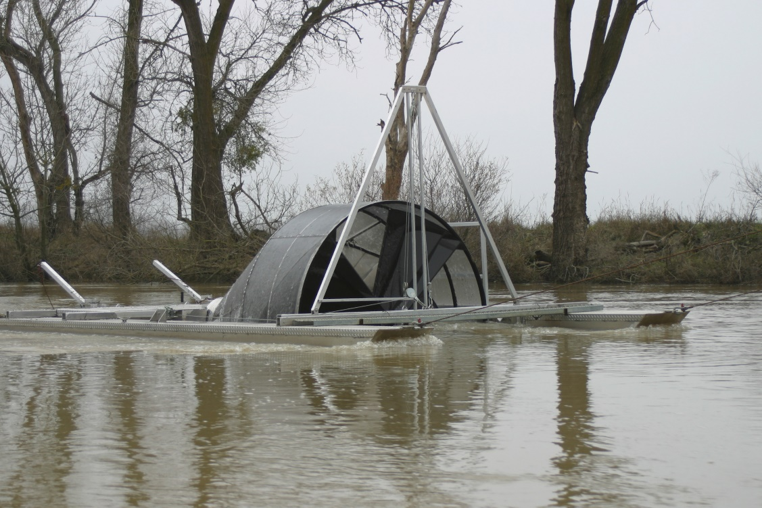

Image 1. Screw trap sampling in the Toe Drain.

* + Release the boat from the top of the truck and carry it as a team to the water’s edge. Attach a bow line immediately and secure the boat so it doesn’t drift away.
  + Load up the boat with all necessary equipment:
    - Motor and gas (during high flows) or electric motor and battery (during low flows)
    - Crowder
    - Live well screen (if setting the trap)
    - Large nets
    - Rake
    - Broom (if trap cleaning is necessary)
    - Secchi
    - 2 oars
    - 2 5-gallon buckets
    - 2 aerators
    - Small nets
    - Measuring boards
    - Cut resistant gloves
    - Fish clipboard/binder with key
    - 3 throw bags
    - Type V PFD: throw ring
    - Handheld YSI
  + Motor or paddle out to the screw trap (maximum 3 crew members in the boat at a time), tie off the bow line to the trap cleat hitch, begin to unload equipment onto the trap.
  + The data recording crew member will begin to record water quality data, weather conditions, and sampling details. For more details on discrete water quality done with each sampling event, reference the Lower Trophic Sampling SOP.
  + Begin to move large debris out of the way first, if present. Communication is key during this part of operation. Movement of debris can cause swift movement of the trap or boat, so be sure to vocalize what you are doing so that all crew members can have time to secure themselves with three points of contact.
  + Remove the lock on the live well door, open the live well, and secure with the bungee to avoid accidental closure. If it windy, also position the rake to hold the door open as secondary backup.
    - For a SET day, the live well screen must be put into place and the cone must be lowered all the way. Once lowered, remove the eyebolt that runs through a designated hole in the live well so that the foam neck is released and flush with the bottom of the cone. The cone revolutions and time when the cone is lowered should be recorded on the datasheet. The pontoon will be cleaned on set days using a broom and/or bucket of water.
    - It may be necessary to have a crew member in the livewell ensuring that the cone does not pinch the foam collar as it is lowered.

NOTE: The remaining steps of the general operations are for check and pull days.

* + If the cone is not spinning (due to debris or flood tide) one to two crew members will spin the cone while another crew member wades in the live well and monitors what is coming through the cone. This crew member will stand with their feet wide apart to avoid putting weight on the center mesh panel.
    - If there is a clog, the crew member in the live well can ask the other crew members to hold the cone still while they free the debris from the cone by pulling it by hand into the live well. *This crew member should always be wearing cut resistant gloves. *Clearing this way should **not** be done during high flows due to risk of cone spinning and body parts being trapped. If in high flow conditions, lift the cone before ever reaching into it.
    - If there are large branches or clogs, the spinning screw members can hold the trap still while the live well crew member opens a side panel to pull out debris. *This should only be done with very bad clogs, as it risks the loss of fish stuck in pulled out debris.
  + Once all debris have been cleared from the cone, all crew members will work together to sort through any debris. Gloves must be worn during this process to protect from thorns, stringers, and other potential sharps.
  + One crew member will use a large net to net debris and fish from the live well while the other member(s) sort through the netted contents. The netting crew member will be sure that the entire live well is clear of debris before moving onto the next step.
    - All fish and shrimp sampled will be placed in a 5-gallon bucket of water.
    - On hot days, water should be refreshed at least every 30 minutes to ensure fish are kept in good condition.
    - When salmon or other species of interest are caught, more water and an aerator will be added to the bucket to keep the fish in good condition until ready to be fully processed.
  + Simultaneously, one crew member will begin to put the crowder into the live well and another will raise the cone out of the water.
    - The crowder is put in by aligning it as close to possible to the cone side of the live well, pushing the crowder all the way to the bottom corner, then inching it along the bottom of the live well until all remaining fish are trapped on the opposite end.
    - The cone is raised by using the hand crank to lift it high enough out of the water to stop spinning and allow a crew member to view the hub-odometer to read the revolutions count.
    - Time of lifting the cone and revolution count must be recorded on both the fish datasheet, and the RSTR log sheet.
    - Unless the trap is being pulled, the cone does not need to be raised completely out of the water. If flows are not high, it can be lowered back down as soon as the revolutions have been recorded.
    - When done, ensure the crank handle is parallel to the pontoon so it does not become a tripping hazard.
  + The crew member who was netting before, will continue to net in the portion of the live well that remaining fish were trapped in. The other crew member(s) will sort through the netted contents.
    - When the netting crew member has done 2 quality net samples resulting in zeros (no fish or shrimp), another crew member will do a third net sample to confirm. If the 3rd sample is not a zero, the crew member should continue until they get 3 zeros in a row.
  + Remove the crowder and replace the fish hotel in the live well and close the lid. Then place the lock on the trapdoor. Lower the cone if it has not been done already, unless it is a pull day.
    - If it is a PULL day, pin the foam sleeve at the back of the cone down by placing the eye bolt through the designated hole in the live well. Then, lift the cone all the way up, secure the safety cable, and lower slightly until there is little to no tension on the lifting cable). Remove the mesh screen from the back of the live well.

### Fish Processing:

* + Process the fish sampled. This can be done on the screw trap pontoon if weather is suitable and all crew members are in good condition. Otherwise, bring the fish back to shore.
    - Crew members will use a small net to capture a small number of fish and place them onto a wetted measuring board. Each fish will be identified by species and measured (fork length). Once the fish has been measured, it should be released downstream of the trap.
    - Fish must be greater than or equal to 25mm to be considered part of the sample.
    - For each species, once 20 invasive or 50 native individuals have been measured, begin plus counting any individuals greater than or equal to 25 mm.

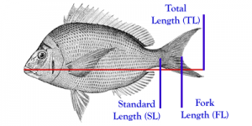

Photo from fishionary.fisheries.org

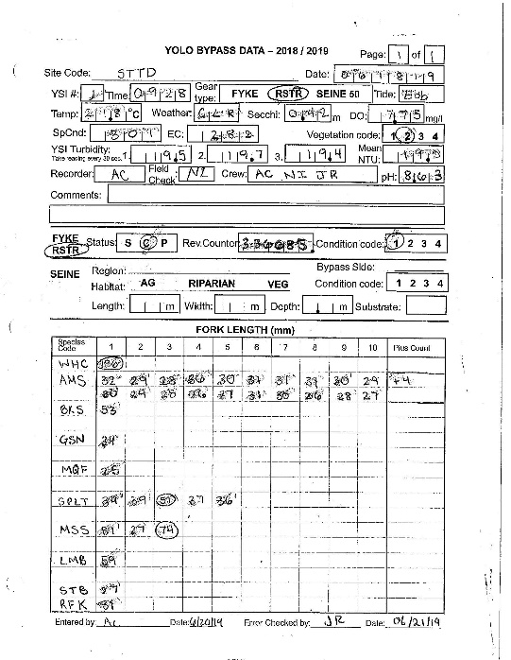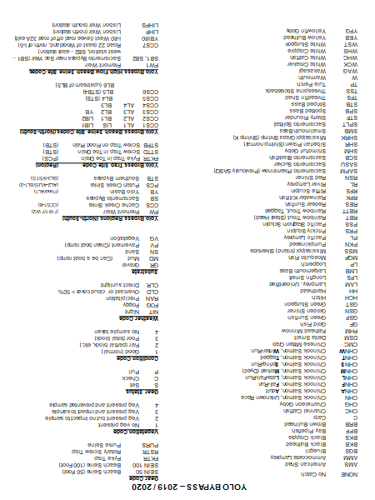

* + The data recorder will not measure fish but instead will record what the other crew members list off.
    - * If a fish is dead, it will be mentioned to the data recorder and they will circle the FL measurement to indicate it is dead. If a shrimp has eggs, it will be mentioned to the data recorder and they will add a small “e” to the upper right corner of the box containing its FL.
      * At the end of each sampling event, another crew member must check over the data sheet to look for any inconsistencies or missing data.
    - Species of interest, such as salmon or Sacramento Blackfish, should be processed on land with the genetics kit. For more information on how to process species of interest, refer to the Genetics SOP.
  + Before leaving the trap, check that all supplies are returned to the boat, clean off the pontoon surfaces, and double check that the live well is locked.

### Guidelines for operation after major storm events

1. Much of the severe debris associated with a storm will move through the Toe Drain during the first 48 hours. Every storm will bring different conditions to the Bypass, depending on conditions before the storm occurs, whether it is an isolated event or part of a series of storms, whether it causes the Fremont Weir to overtop, and how much wind is involved. The complexity and number of factors considered with each event, make it impossible to set a hard-and-fast rule for a period of time to wait before fishing the screw trap, or when to pull it to shore in anticipation of a storm. However, when major debris loads are anticipated, due to wind that might cause trees or tree limbs to fall, and/or the Fremont Weir is expected to overtop for the first time in a long period, a general guideline to follow is to allow 48 hours to pass before fishing the trap. The trap and debris loads should be checked during this period. If debris loads are light and conditions are favorable, it may be possible to fish the trap for short periods while crews are continually assessing and watching for incoming debris.
2. When fishing the trap during periods in which large debris items are possible, the trap should be fished in an attended fashion, with the crew continually on the trap while it is fishing. This will allow the crew to respond to heavy debris loads and raise the cone as soon as there are warnings of debris from the crew member designated as the debris-spotter.
3. When a crew is on the trap during periods of high flow and high potential for debris (during fishing, while processing fish, or for maintenance purposes), there should always be three crew members present, with one person assigned to watching for trees or other serious debris floating downstream (“debris spotter”). This person should not be distracted by other duties, such as processing fish. This person may be able to see dangerous debris, give warning to the rest of the crew to raise the cone if necessary and/or get into the boat in order to be out of the path of the debris. The boat motor should be left on, idling in neutral, during these conditions to enable a quick retreat from the trap or man overboard rescue, should one become necessary.

## Appendix I: Permitting

All necessary permits must be obtained from appropriate local, state, federal agencies. Sufficient time must be allotted during the planning period to secure permits. A list of the necessary permits required for installation of the rotary trap is listed below:

* **Scientific Collection Permit (SCP):** The California Department of Fish and Wildlife (DFW) requires that the YBFMP have a valid SCP for all field collection activities.  The SCP covers all sampling activities and take of non-listed species.
* **NMFS Section 10(a)(1)(A):** The National Marine Fisheries Service (NMFS) requires that the YBFMP have an Endangered Species Act (ESA) permit for the take of federally listed salmonids (winter and spring run Chinook Salmon and Central Valley Steelhead) and Green Sturgeon.  This permit is coordinated through the Interagency Ecological Program (IEP).
* **FWS Section 7:** The US Fish and Wildlife Service (FWS) requires that the YBFMP have an ESA permit for the take of federally listed Delta Smelt.  This permit is coordinated through IEP.
* **Marine Mammal Protection Act (MMPA):** NMFS requires the YBFMP to have a MMPA permit to cover the potential take or harassment of marine mammals by our sampling activities.  This permit is coordinated through IEP.
* **California Endangered Species Act (CESA) Memorandum of Understanding (MOU):** DFW requires the YBFMP to have a CESA MOU to cover the take of state listed salmonids (winter and spring run Chinook Salmon) and osmerids (Delta and Longfin Smelt).

Each permit carries with it various stipulations for trap deployment that must be rigidly adhered to. Several contain language requiring periodic reporting of operations and data while others need only be kept appraised of the continuation of trapping efforts from year to year.

## Appendix II: Hubodometer

High debris areas and tidal channels will result in the trap ceasing to rotate. To estimate when rotation of the trap ceased, the use of a trucking industry hub-odometer is recommended. The hub-odometer is placed on the front or rear of the central shaft of the trap and records the “distance” that the screw turns between trap checks. By monitoring the number of revolutions per minute, and knowing the distance that the screw turned, the length of time the trap fished before jamming can be estimated. The hub-odometer that we use records 1.6 km for every 500 revolutions of the trap shaft. Thus, the length of time the trap fished can be estimated by

hours trapped =[total revolutions/(measured revolutions/minute)] ÷ 60,

where

total revolutions =

(ending odometer reading–beginning odometer reading) × 500

hub-odometer attached to screwtrap

**Hub-odometer attached to shaft of rotary screw trap. Hub-odometer readings are used to determine the number of hours the trap fished if trap is stopped by debris when staff is not present.**

## Appendix III: Annual Maintenance

At the end of each sampling season the screwtrap livewell should be removed, serviced, and stored at the West Sac office. It should then be maintained and reattached to the trap prior to the start of the next season.

### Equipment:

* Toolbox
* 2 socket & crescent wrench sets – check for 7/16” and 9/16” sizes
* 2 + ratchet straps
* Power drill with socket adapter and charged batteries
* At least 50” of rope x 2
* Wood boards for truck bed
* Jon boat, motor, gas
* Bag to store bolts, nuts, and washers
* 2-3 metal poles/bars
* Round orange buoy
* Hand riveter or rivet gun
* Rivets
* One open-bed truck
* Throw bag
* PFDs
* Waders

### Methods:

#### Livewell Removal

Takes place after sampling season, ideally sometime in July. At least 4 staff required for 4-6 hours of work.

1. Gather equipment and load supplies
   1. Charge drill batteries prior to maintenance day
   2. Check all safety gear
2. At the site, inspect surroundings for safety hazards, such a debris and swift flows
3. Bringing the trap to shore
   1. Crew should use the jon boat with motor to access screw trap
   2. Tie a long rope to the cleat closest to the ramp and hand off the other end of the rope to crew on shore

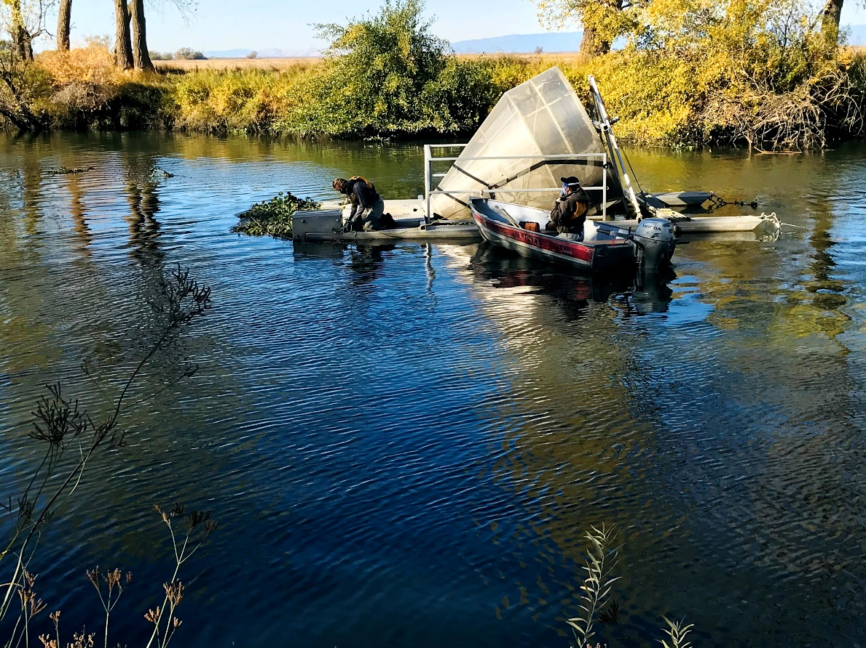

Crew member attaching rope to back of screw trap.

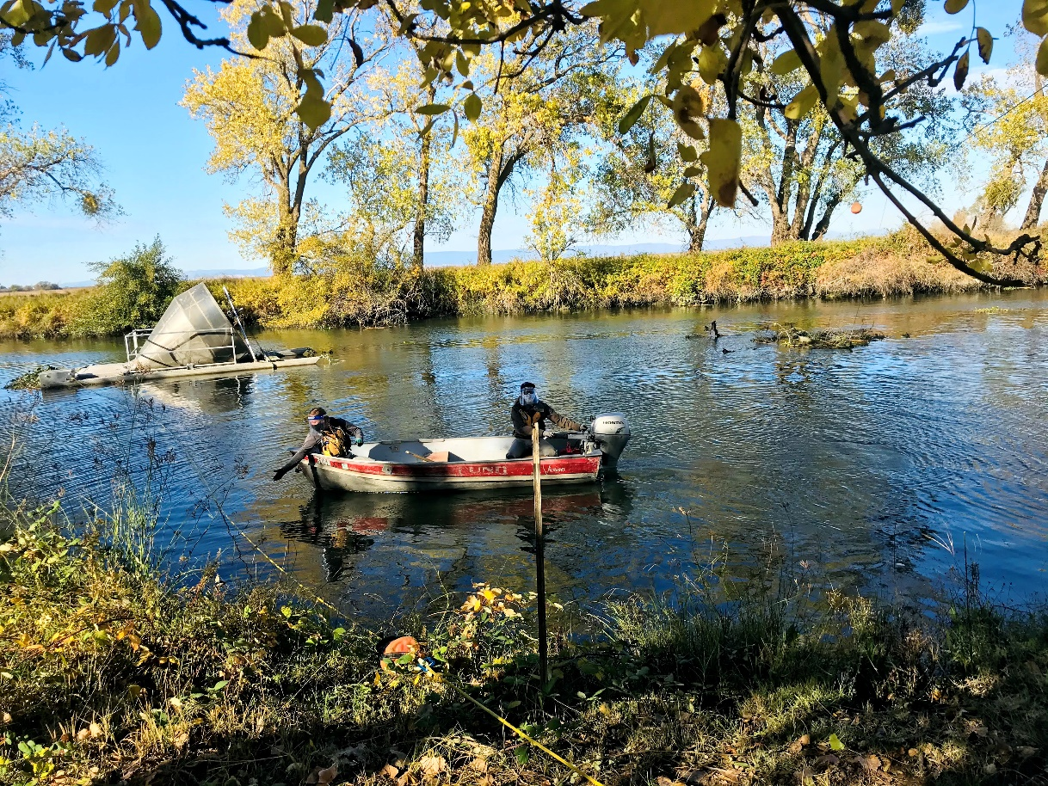

Crew in boat stringing rope from trap to shore.

* 1. Return to trap and untie anchor from back eye ring of the trap
     1. Secure a buoy to the end of the anchor line before releasing slack

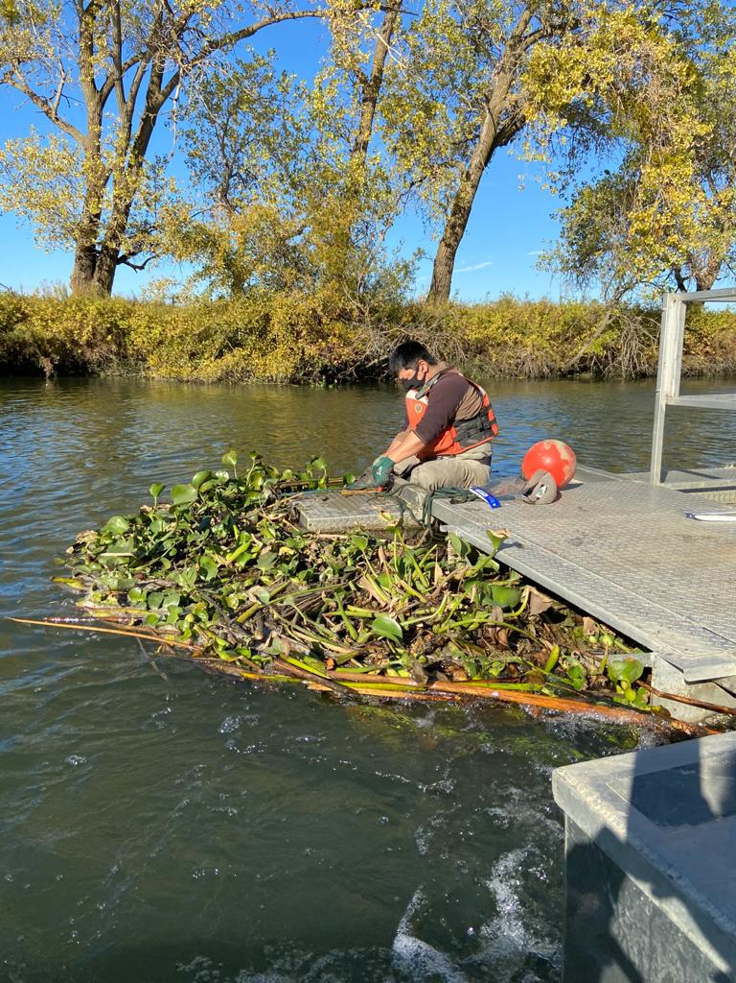

Crew member removing anchor line prior to attaching buoy.

* + 1. This task is easier to do during ebb tide as it provides slack in the anchor line
  1. Have shore crew pull the trap to the side of the channel
     1. Tie rope off to a tree on the right side of the ramp
     2. Add another rope to the opposite side of the trap and tie off to a tree on the left side of the ramp
     3. Adjust ropes until the trap is sitting roughly perpendicular to the channel deep enough so that the livewell is not resting on the ramp but shallow enough that crew can wade to the trap

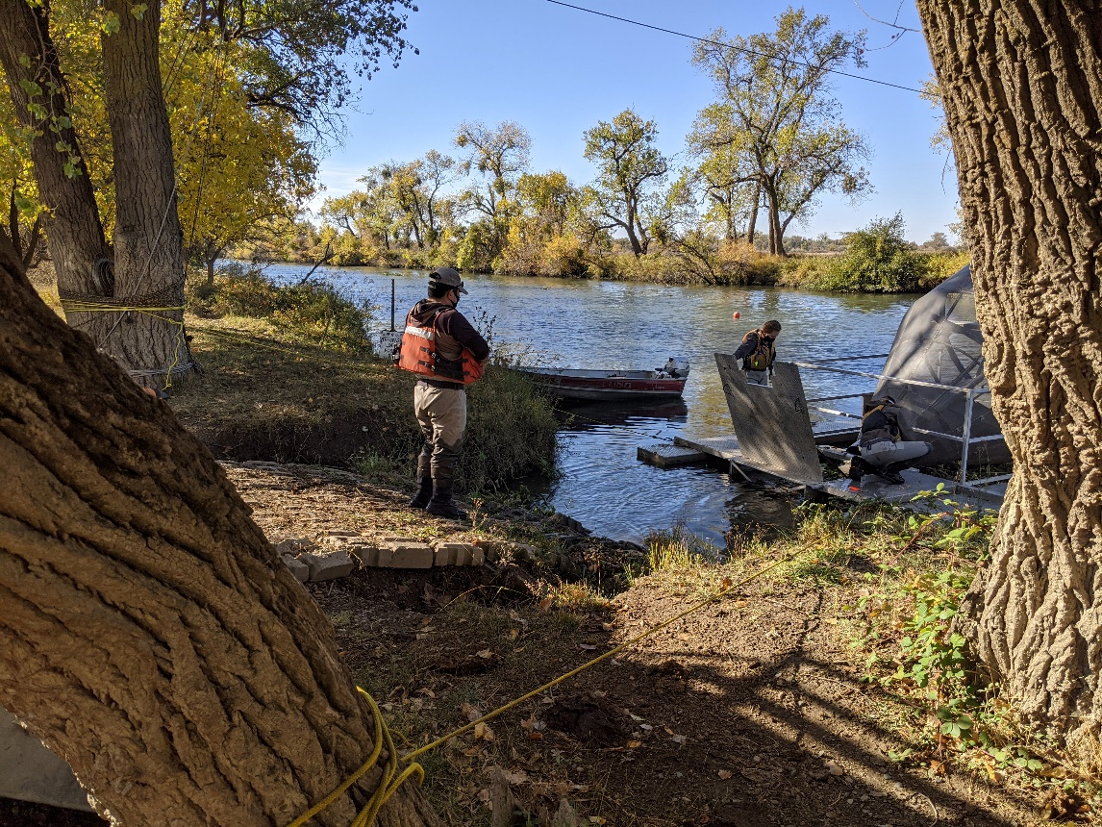

Screw trap positioned properly next to ramp.

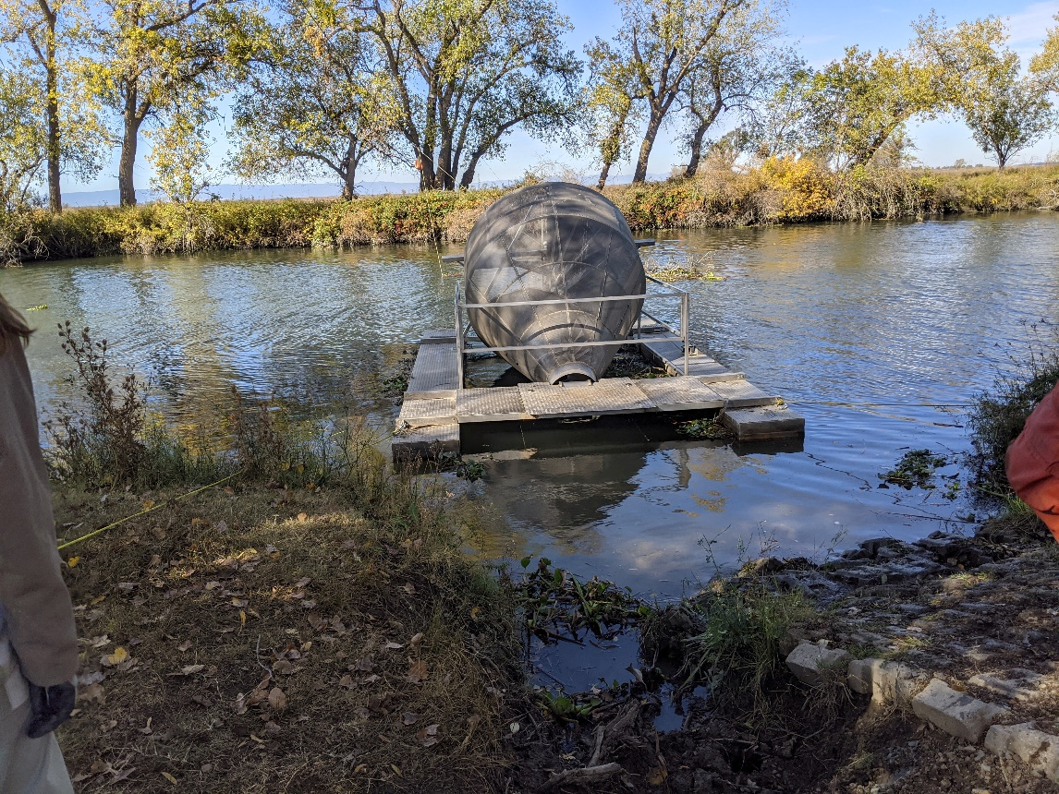

Another angle of the screw trap positioned properly next to ramp.

1. Removing the livewell
   1. Begin by removing the sonde housing, if present
      1. Bring housing back to warehouse for safe keeping
   2. Next, remove the livewell lid
      1. Unbolt the top bolts and the bolt connecting the inside webbing to the lid with 7/16” sockets and crescent wrenches
      2. Be careful not to drop washers and nuts when removing the bolts
      3. Store bolts in a bag or bucket for safe keeping

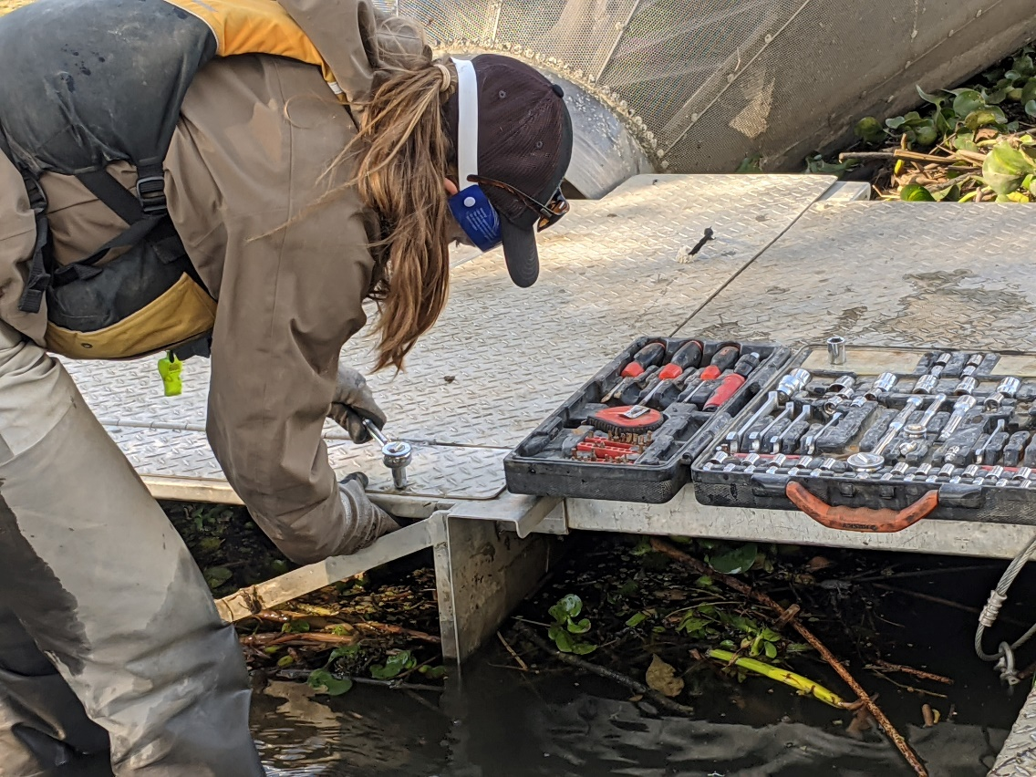

Crew member loosing bolts on livewell lid.

* 1. Next remove the livewell itself
     1. Start by using the 9/16” sockets to remove the 4 bolts (2 on each side) connecting the upper panels on either side of the box from the box frame
     2. Then loosen the 4 bolts (2 on each side) on the inside of the livewell, connecting its frame to the mounts perpendicular to the pontoons

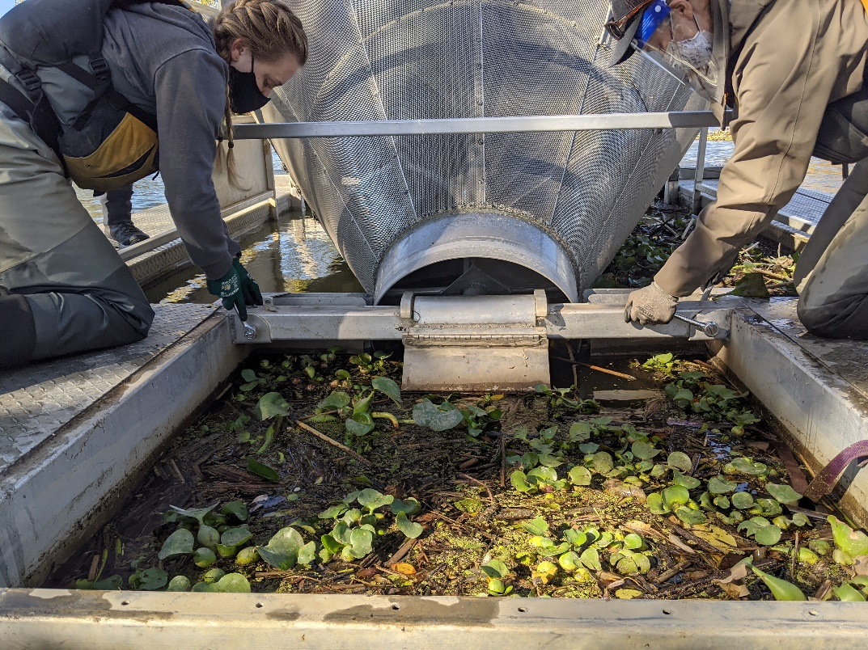

Two crew members loosening bolts near the cone.

* + 1. Once done, remove the 2 loosened bolts on the back end of the livewell
       1. You may need 1-2 people to support the back of the livewell to reduce pinching on the bolt
    2. Next remove the 2 loosened bolts near the cone while supporting the livewell so it does not drop when the bolts are removed
    3. Gently lower the livewell to the ground

1. Loading the livewell
   1. Loosen the ropes tied to the trees which are holding the trap in place and allow the trap to drift away from the livewell, then tie off the ropes again
   2. With 1 person on each corner, slowly walk the livewell up the ramp, pausing to drain water from the back so it is easier to carry
   3. Place livewell in the back of the open-bed pickup truck
      1. Ensure at least two wood boards are in place to protect the bed
      2. Tie down the livewell with ratchet straps

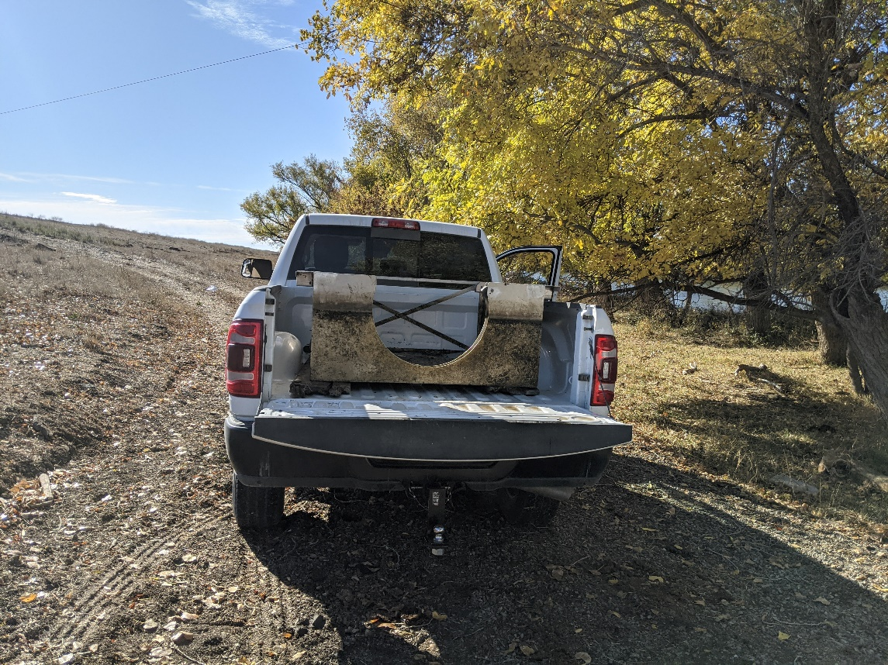

Livewell resting in truck bed on pieces of wood.

1. Reattaching the livewell lid
   1. Reverse the steps in section C-a to reattach the lid
      1. Attach a minimum of two bolts, the rest can be added when the livewell is reattached
2. Maintaining the cone
   1. Inspect the cone for corroded rivets
      1. If there are spots needing reinforcement, make a note of how many rivets will be needed and acquire them before livewell replacement
3. Returning the trap to its correct location in the channel
   1. Unhook ropes from the screwtrap and allow it to drift back into center channel
      1. This is easier done during ebb tide
      2. If necessary, use the jon boat to pull trap into position
   2. Retrieve anchor line, unhook buoy, and reattach to screwtrap eye ring or a shackle attached to the eye ring
      1. If this is done during flood or slack tide, you may need to use the boat to pull the trap downstream to provide enough slack in the anchor line for reattachment
      2. Secure with a bowline knot and half hitch
         1. Do not make a complicated knot that will be impossible for the next crew to remove!

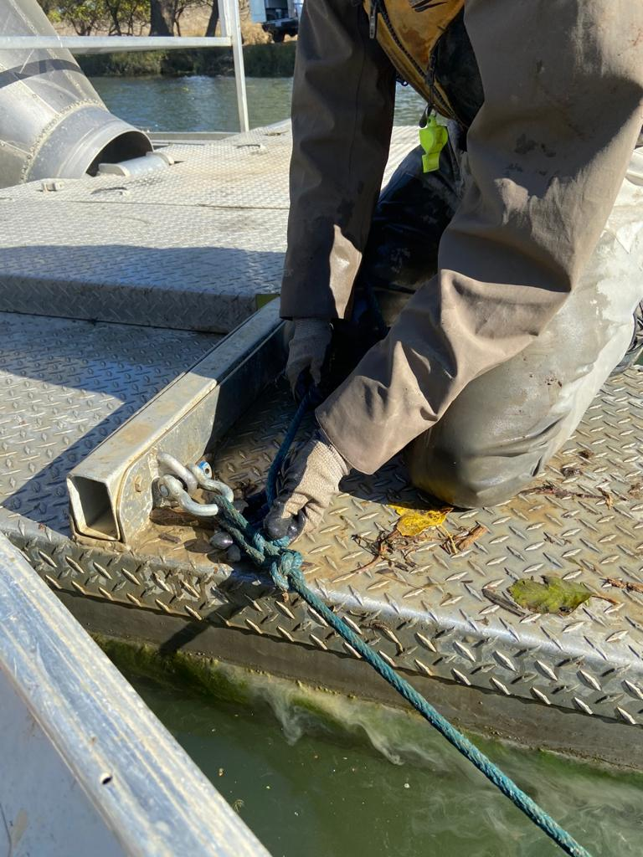

Proper knot for attaching anchor line to trap.

#### Livewell Maintenance

Takes place at the warehouse, after removal and sometime before re-attachment. At least 2

staff required for 2-6 hours of work.

1. Prior to maintenance, purchase any necessary supplies. Parts that often need replacement include:
   1. Eye protections and masks
   2. Scrubbing pads & wire scrub brush
   3. Rivet gun and rivets
   4. 4 Anodes (Magnesium, 3 ¾” diameter, ½” thickness) [<https://www.westmarinepro.com/buy/martyr--magnesium-rudder-and-trim-tab-anodes--POO5533146?pCode=11140050>]

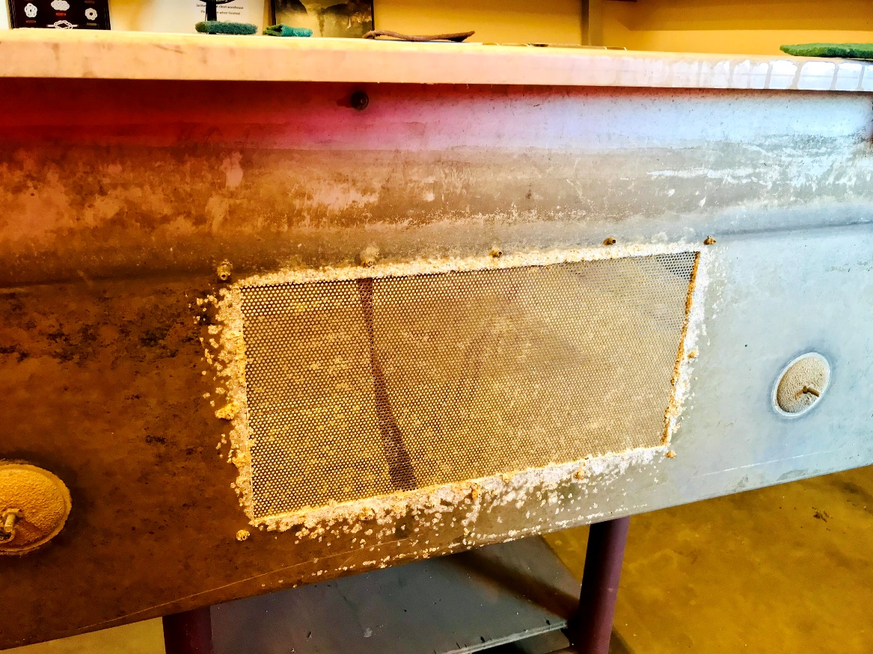

Corroded livewell mesh and anodes after one year in the water.

1. When you have the livewell back at the office.
   1. Power wash and dry out the livewell prior to the cleaning
   2. Be sure to wear the eye protection and masks. Scrub off the any corrosion and excess debris with scrubbing pads. Use the wire scrub brush if it’s necessary.
   3. Inspect the rivets and replace them if it’s necessary.
   4. Replace the all Anodes. Be sure to place the excess end of bolts outwards like on the picture above.

#### Livewell Re-attachment

Takes place prior to new sampling season, ideally sometime in December. At least 4 staff required for 4-6 hours of work.

1. Bring trap to shore following the same steps listed in the Livewell Removal section
2. Remove the lid
   1. Remove the lid the same way as in the Livewell Removal section
3. Reattaching the livewell
   1. Have 4 crew carefully walk the livewell down the ramp and position it under the cone
   2. Position two people in water behind the trap to lift the back of the livewell and 2 people on opposite sides of the trap platform lifting the front of the livewell
   3. Carefully place the 4 bolts that were removed in the last step of Livewell Removal through their respective holes to secure the trap
   4. Using the 9/16” socket, tighten these bolts
   5. Add the remaining 4 large bolts to the sides of the platform
4. Reattach the lid
   1. Reverse the steps from the lid removal process during the Livewell Removal to attach the lid, ensure all bolts are reattached this time
5. Maintaining the cone
   1. If it was determined that new rivets were needed during the livewell removal process use a hand riveter or rivet gun to add a new rivet
6. Reattach sonde housing if applicable
7. Return trap to channel following the same steps listed in the Livewell Removal section

## Past SOP editors and collaborators:

* Unknown Date – Kevin Reece: Creation of this RSTR protocol
* 1/2012 – Jared Frantzich: Edits made to the content of this document
* 4/2020 – Nicole Kwan and Amanda Casby: Reorganization of material to fit SOP template and ADA guidelines, addition of general operations section, addition of equipment list, addition of annual maintenance outline, removal of installation and removal information in order to put it into a separate document, and small language and protocol edits to appendices.
* 6/17/2020 – Nicole Kwan: Finished editing for consistency with other fish sampling SOPs; added photos.
* 11/25/2020 – Nicole Kwan: Adding text and photos to annual maintenance section.
* 12/30/2020 – Naoaki Ikemiyagi: Added details for livewell repair.
* 10/25/2021 – Nicole Kwan & Parisa Farman: Clarified language throughout, updated organization names following division ReOrg, removed broken hyperlinks, added note about livewell foam collar, and added extra safety details.